Navigating Change in Your Church

By Lee Kricher, Founder of Future Forward Churches and author of
For a New Generation: A Practical Guide for Revitalizing Your Church

In 2003, the church at which I served as pastor was an aging, dying church. After years of declining attendance, we were on the verge of closing our doors. The average age of our church attendees was over 50 years old - more than 15 years older than the average age of our community. I knew that prayer would provide the foundation of hope for our future as a church. I also knew that we had to change some things.

We did not have to change our core beliefs and values. They were not the problem. The problem was that our approach to church was stuck in the distant past. Our services, programs, ministries and practices were perfectly designed to reach the people we were reaching. While preserving our core beliefs and values, we had to find a way to make the kind of changes to our services, programs, ministries and practices that were needed to reach people we were not reaching – particularly the next generation.

The combination of prayer and change leadership resulted in a dramatic turnaround in our church. As covered in detail in the book For a New Generation: A Practical Guide for Revitalizing Your Church, below are the five change leadership principles or strategies that we put into pace (along with relevant quotes from effective change leaders):

#1 - Adopt a New Mindset - Do whatever is needed to shift the mindset of the people of your church away from the statement “If it was good enough for me, it should be good enough for our children and grandchildren,” and replace it with the question – “What will it take to reach and continue to reach the next generation?”

The most pervasive and common thread of our autopsies was that the deceased churches lived for a long time with the past as hero. They held on more tightly with each progressive year. They often clung to things of the past with desperation and fear. And when any internal or external force tried to change the past, they responded with anger and resolution: “We will die before we change.” And they did.
Thom S. Rainer, Autopsy of a Deceased Church

#2 - Identify the Essentials – Clarify the vision that you believe that God wants for your church and then identify your “vision essentials” - the handful of things that deserve your full time, attention, energy and resources because they are absolutely essential to achieving your vision.

Contrary to popular wisdom, the proper first response to a changing world is not to ask, “How should we change?” but rather to ask, “What do we stand for and why do we exist?” This should never change. And then feel free to change everything else.
Jim Collins and Jerry I. Porras, Built to Last

#3 - Reduce the Distractions – Identify and eliminate as many church programs, ministries and practices as possible that potentially distract members and visitors from your vision and divert your time, attention, energy and resources from the things that are essential to fulfilling your vision.

Your programs are not sacred… What is sacred is the mission of the church. You are called to shine a light and demonstrate God’s love and grace to those who need it. Our mission is not to preserve the local church as it presently exists in its various forms or models; our mission is to be the church… All along (God) has planned this thing called the church so we could send a collective message to a generation that needs to know Him.
Reggie Joiner, founder of The reThink Group

#4 – Elevate Your Standards - Close the gap between where you are as a church and where you have the potential to be regarding the excellence of your weekend services and other “vision essentials.”

Capable leaders are willing to set standards that scare them. Ask yourself the question, “Are you operating at good, better or best?” Good is doing what is expected of you. It is slightly above average and requires some focus and determination to get there, but it is relatively easy to achieve. Better is rising a little higher than good. It typically means you are comparing yourself to the next one in line. But best is where you want to live. It is greatness and doesn’t mean you are better than everyone else but that you’re working to your maximum capability.
Brad Lomenick, The Catalyst Leader

#5– Build a Mentoring Culture – Put into place systems that ensure that young leaders are prepared for and placed into visible leadership roles in the church and that the church will become and remain a church that is never disconnected from the next generation.

Just about anybody can make an organization look good for a moment – by launching a flashy new program or product, drawing crowds to a big event, or slashing the budget to boost the bottom line. But leaders who leave a legacy take a different approach. They lead with tomorrow as well as today in mind… When all is said and done, your ability as a leader will not be judged by what you achieved personally or even by what your team accomplished during your tenure. You will be judged by how well your people and your organization did after you were gone.
John Maxwell, 21 Irrefutable Laws of Leadership

We did not approach our church revitalization with the short-term goal of just experiencing a season of increased attendance. We approached our church revitalization with a long-term goal of building a lasting, multi-generational church.

Change, of course, is never easy. About a third of the people who were attending our church left within the first two years because they did not resonate with the changes we made. But by the end of that two-year period, our church attendance grew to over 400 people. Within 15 years of implementing much needed changes, the average weekend attendance at Amplify Church grew to over 2000 people. Most importantly, we were transformed into a multi-generational church and the average age of church attendees matched the average age of the community served by the church.

In our rapidly changing world, accepting the status quo is the greatest threat to your church’s core mission and, perhaps, to the very survival of your church. Even if you are not entirely comfortable with the idea of taking on the role of change leader, it is critical to step out of your comfort zone for the good of your community and the long-term viability of your church. In our changing world, change leadership skills must become a part of every church leader’s skill set.

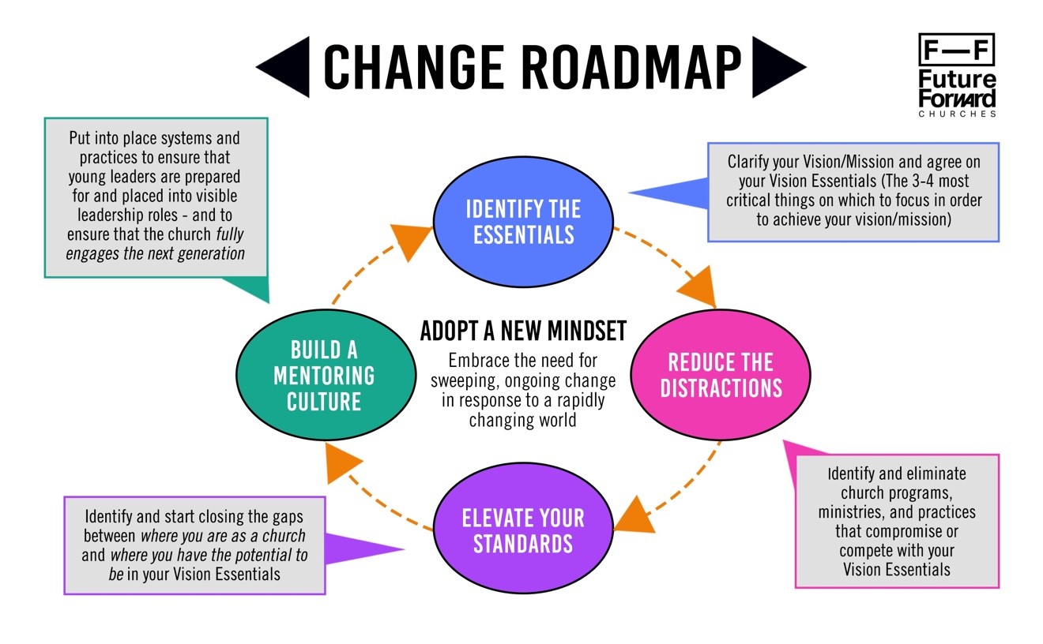

Change Leadership - Key Questions:

#1 - Adopt a New Mindset - In what ways does the mindset of the people of your church need to change? What practical actions can be taken to inspire a positive shift in the mindset of the leaders and members of your church?

#2 - Identify the Essentials - What is the core vision and mission of your church and the primary reason that you exist? What are the truly essential things on which your church should focus to make sure that your church’s core vision and mission continues into the next generation?

#3 - Reduce the Distractions - Which first impressions, programs, ministries and/or practices in your church may be a minor or major distraction to fulfilling your vision and reaching the next generation?

#4 – Elevate Your Standards - In what areas do you need to elevate your standards of excellence as a church in a way that would better fulfill your church vision and reach the next generation?

#5– Build a Mentoring Culture - How can you create a strong and healthy mentoring culture to better reach young people and raise up young leaders in your church?

Change Strategy Worksheet
This worksheet will be helpful to create your church’s Change Roadmap by capturing the specific actions that your church will take that are related to five proven change principles or strategies. (The Amplify Church Strategy Worksheet from the book For a New Generation is attached for reference. It includes specific actions taken and timing/dates only.)

1. Determine the makeup of a Change Leadership Team that will identify appropriate changes. The Change Leadership Team is made up of 4-6 people who are catalysts for organizational change. They are typically key staff members and/or key volunteers who are open to new ideas and who have trusted influence in your church. The Senior Pastor leads the Change Leadership Team. The timeframe for the Change Leadership Team to determine, propose and begin to implement appropriate changes should range from three months to one year.

2. Consider identifying and hiring an external facilitator/coach. An external facilitator/coach (such as a Future Forward Churches coach) can help the members of your Church Leadership Team reach prayerful consensus on the nature and timing of specific changes. This coach could also serve as a sounding board for the pastor during the most crucial months of decision-making and change implementation.

3. The members of the Change Leadership Team should ideally go on one or more Field trips. Field trips (“Vision trips”) allow Church Leadership Team members to experience churches that are effectively reaching the next generation. Getting outside of your own setting and experiencing God’s work in another church can inspire new ideas and break old mindsets in ways that discussions and debates never will. Members of the Change Leadership Team should also read books and listen to podcasts that will provoke new ways of thinking.

4. Determine a timeframe for agreeing on the specific actions that your church will take and ways that you will measure progress. Given the importance of the mission of your church, adopt a bias for action when scheduling Church Leadership Team meetings. Also, make sure to determine measures for tracking progress and record your starting point for each measure. Measures should include the average age of those attending your church and the breakdown of each age demographic in your church. Measures may also include baptisms, giving and changed life stories.

Strategy #1 – Adopt a New Mindset

Specific Actions To Be Taken | Approvals/Resources Needed | Person(s) Responsible For Implementation | Implementation Timing/Dates

Strategy #2 – Identify The Essentials

Specific Actions To Be Taken | Approvals/Resources Needed | Person(s) Responsible For Implementation | Implementation Timing/Dates

Strategy #3 – Reduce The Distractions

Specific Actions To Be Taken | Approvals/Resources Needed | Person(s) Responsible For Implementation | Implementation Timing/Dates

Strategy #4 – Elevate Your Standards

Specific Actions To Be Taken | Approvals/Resources Needed | Person(s) Responsible For Implementation | Implementation Timing/Dates

Strategy #5 – Build a Mentoring Culture

Specific Actions To Be Taken | Approvals/Resources Needed | Person(s) Responsible For Implementation | Implementation Timing/Dates

Change Strategy Worksheet for Amplify Church
(From For a New Generation: A Practical Guide For Revitalizing Your Church)

Strategy #1 – Adopt a New Mindset | Timing/Dates
Guiding Coalition of leaders goes on field trips to see and experience New Generation churches | Months 1-3
Guiding Coalition of leaders read books and articles about church revitalization and reaching the next generation | Months 1-3
Focus multiple weekend messages on the need and reasons to shift the church’s approach from keeping people to reaching people | Months 1-6
Focus multiple weekend messages on the need and reasons to shift the mindset of people in the church from the statement “If it is good enough for me it is good enough for my children” to the question “What will it take to reach our children?” | Months 1-6
Initiate small group Bible studies about the importance of people and churches fulfilling their God-given purpose and vision. All members are encouraged to attend a small group, which are led primarily by members of the Guiding Coalition | Months 3 - 12
Engage as many individuals as possible in face-to-face conversations with a goal of sparking passion for building a New Generation Church | Year One
Strategy #2 – Identify The Essentials | Timing/Dates
Present a clear, concise, inspiring and useful vision statement to the board of directors and congregation | Months 1-3
Focus multiple weekend messages on the meaning of the newly adopted church vision – state vision in every weekend service | Month 1 and ongoing
Identify the “vision essentials” that are most critical in achieving our vision – the weekend service, small groups and children & youth ministry | Months 1-3
Focus multiple weekend messages on the importance of directing our time, energy and attention to the “vision essentials” | Month 1 and ongoing
End Midweek services to increase time, energy and attention on weekend services | Month 1
End Sunday School and regular Men’s and Women’s Ministry meetings to increase time, energy and attention on small groups | Months 3-6

Hire part-time Youth Director (also serves as Music Director) | Month 1
Invest in excellent children and youth curriculum and train leaders and volunteers in how to best use the curriculum | Month 3 and ongoing
Create new “irresistible” environments in which children and youth met | Month 3 and ongoing
Increase overall missions giving but focused on a small number of organizations | Month 3 and ongoing
Strategy #3 – Reduce The Distractions | Timing/Dates
Cover dated church sign at main entrance with canvas sign created by local printer | Month 1
Pave gravel and dirt parking lot | After Year 2
Arrange for Removal of radio tower from top of roof | Months 1-3
Remove bulletin boards from church foyer and paint church foyer | Months 1-6
Remove dated, used furniture from foyer area and sanctuary | Months 1-3
Replace aging green pews and stained rust colored chairs with modern individual seating | After Year 2
End Evangelism Training Program as competition to small groups | Months 1- 3
Relocate Food Bank to a church closer to food bank recipients to free up space for children and youth program | Year 2
Relocate Drug Rehab Program to another church to free up space for children and youth program | Year 2
Close K-12 Christian School, freeing up space for children and youth program | After Year 2
Remove special pastors chair on platform and special parking places for staff | Month 1
End formal dress code for weekend services | Month 1
Move verbal prayer requests from weekend services to small groups | Months 1-3
Stop political action activities including distribution of “voters guides” | Year 1
Eliminate “open microphone,” prayer lines and establish “Join in without standing out” policy for worshippers at weekend services | Months 1-3
Change name of church to better reflect vision of church | Month 1
Strategy #4 – Elevate Your Standards | Timing/Dates
Update church website dramatically | Year 1
Form Creative Team of staff and volunteers to plan how to increase the impact of weekend services | Months 1-3
Add volunteer greeters | Year 1
Add volunteer parking lot attendants | Year 2
Create Café off of foyer staffed by volunteers | Year 2
Create “VIP” Team to greet first time visitors | After Year 2
Replace silence with upbeat contemporary worship music before and after weekend services | Month 1
Reduce length of services from over 90 minutes to approximately 65 minutes including a significant reduction in time devoted to announcements | Month 1
Begin to use modern Bible translations (NIV, NLT, etc) to make it easier for visitors to engage with the text | Month 1
Move two crosses to adjacent walls in order to install video screens so words of worship songs and Bible passages can be projected | Year 1
Change music style to “Hillsong/Passion” contemporary worship style | Month 1
Hold auditions for worship team and significantly increase rehearsal time to increase excellence of music | Month 1
Install audio, video and lighting components in sanctuary to better match new style of worship music | Year 2 and ongoing
Change color of sanctuary walls from white to darker colors to increase “intimacy” of weekend worship experience | After Year 2
Begin to present “one-point” weekend messages in 4-6 week series to make them more memorable for listeners | Month 1
Strategy #5 – Build a Mentoring Culture | Timing/Dates
Focus multiple weekend messages on the need and reasons to mentor the next generation to ensure the future viability of the church | Year 1
Identify core leadership roles and the desired attributes for each role as part of Amplify Leadership Development System | After Year 2
Institute a default policy of hiring from within people who have shown faithfulness as volunteers | Year 1 and ongoing
Institute “Three-Deep Mentoring” policy so that every church leader identifies two people they are mentoring for each of their key roles | After Year 2
Change By-Laws for Succession Planning purposes | Year 2
Appoint successor to Senior Pastor | After Year 2
Institute 75% Rule to increase number of young adults in visible leadership roles during weekend services | After Year 2
Institute rigorous policies and procedures prioritizing the safety and well-being of children | After Year 2
Expand target audience for mentoring to include various church leaders visiting Amplify Church for encouragement or inspiration | After Year 2

Lee Kricher is the Founding Pastor of Amplify Church in Pittsburgh, PA, a church that experienced a dramatic turnaround from an aging, dying church of under 200 people to a multi-generational church of over 2,000 people. He is also the Founder of Future Forward Churches and the author of For a New Generation: A Practical Guide For Revitalizing Your Church. You can contact him at lee@futureforwardchurches.com

